**Experiment 10**

**Lab Book:**



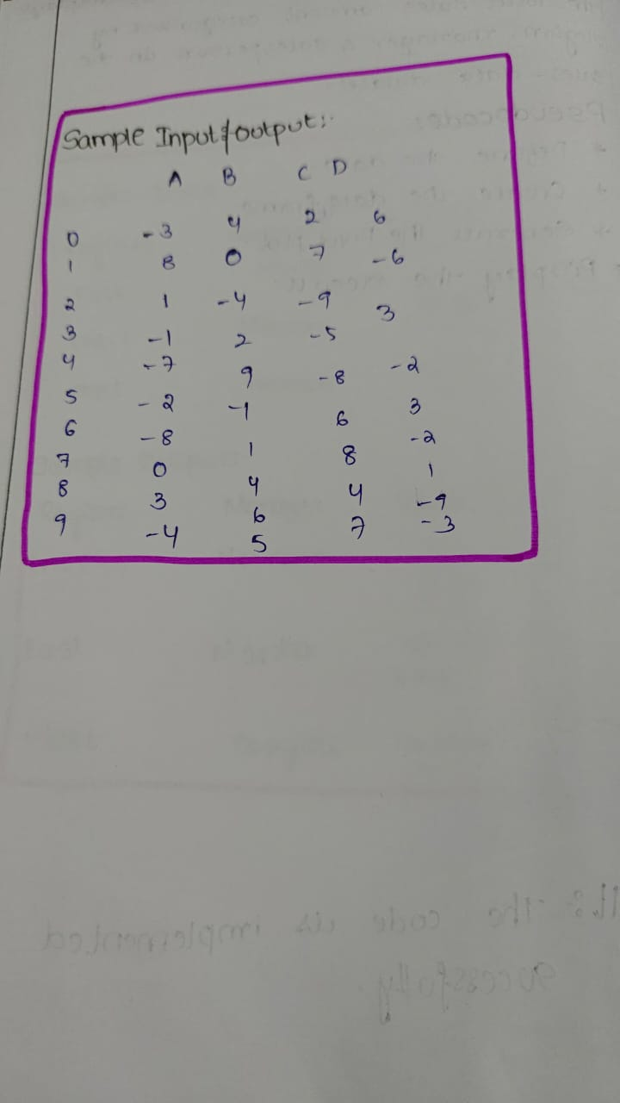

**Code:**

import pandas as pd

import numpy as np

np.random.seed(0)

data = np.random.randn(10, 4)

df = pd.DataFrame(data, columns=['A', 'B', 'C', 'D'])

def format_dataframe(df):

    formatted_df = df.copy()

    for col in formatted_df.columns:

        formatted_df[col] = formatted_df[col].apply(lambda x: f"\033[91m{x}\033[0m" if x < 0 else f"\033[30m{x}\033[0m")

    return formatted_df

formatted_df = format_dataframe(df)

print(formatted_df)

**Sample Output**

